**Name**: Qadri Nabil Qadri Kamal

**ID: 585**

**Group: 5**

**Section : 26**

**Topic**: Computer Engineering Role In COVID-19 Pandemic.

**Application Brief**: I am interested in this topic because it is a topic that concerns public opinion and I would like to talk about it

**GitHub-Link:**

**GitHub-Page(Published Website):**

**Screenshots**:



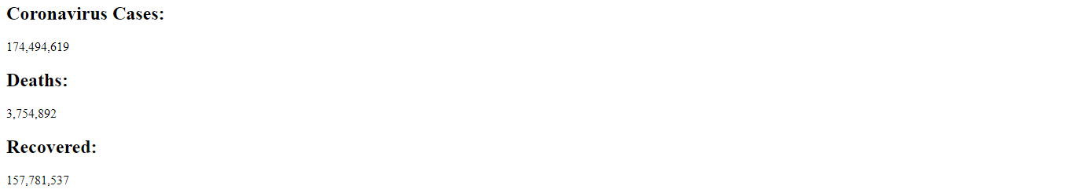

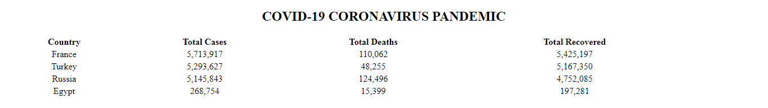

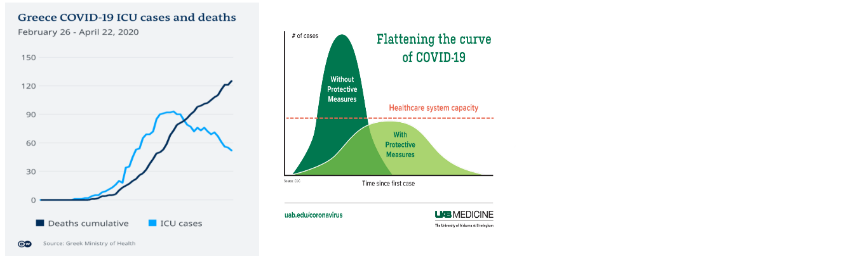

**Source Code**:

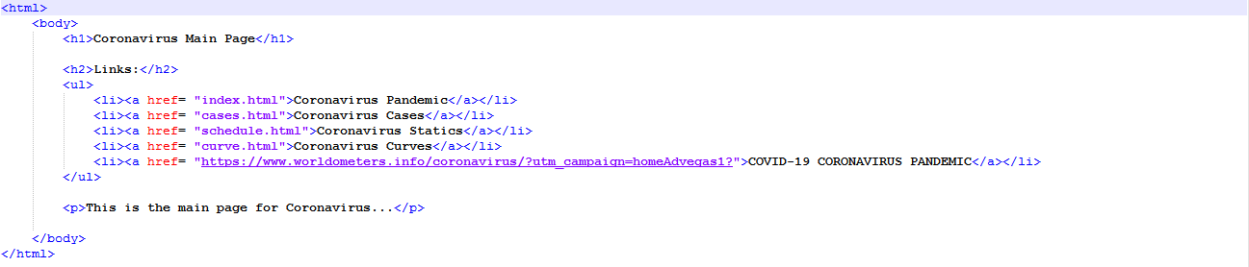

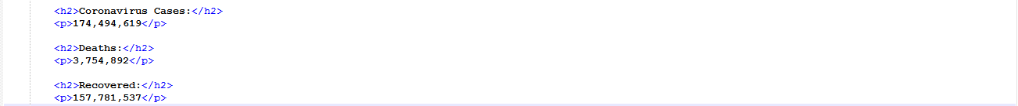

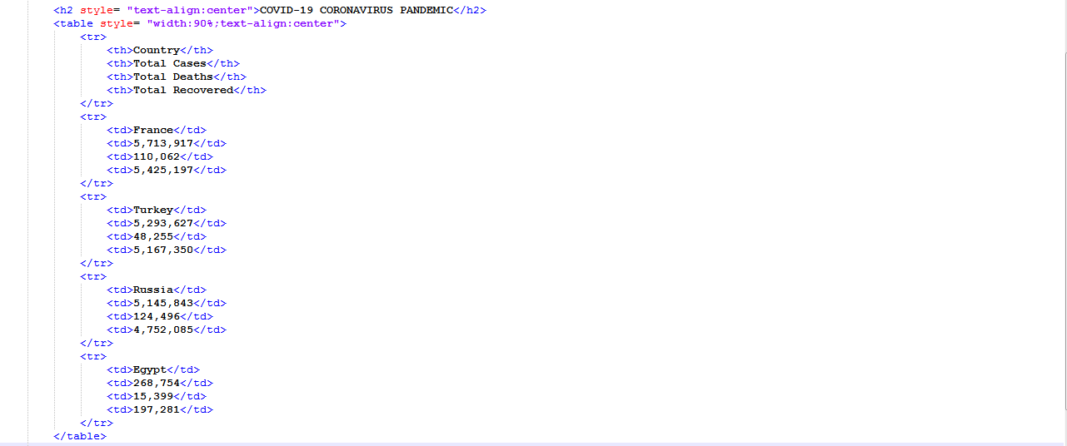

8